Cross-quantilogram: AUDUSD and EURGBP
Method 20 / daily log returns / expanding quantiles / Alpari D1 full available history

Study setup
Logical pair: AUDUSD , EURGBP
Broker symbols: AUDUSD_i , EURGBP_i
Snapshot: 2026-11-03_majors_alpari_D1
Timeframe: D1
Matched return window: 1999-01-06 to 2026-11-02 (UTC bar dates)
Matched return count n: 7198
Dropped unfinished last bar dated 2026-11-03 UTC after a tick-volume check against the prior complete day.
Quantiles: expanding window, min history 252 days
tau in [0.05, 0.2]; k=0..10; headline tau=0.05, k=1
Complete matched rows (Excel): AUDUSD-EURGBP_CQ_D1.xlsx
Complete matched rows (HTML table): AUDUSD-EURGBP_CQ_D1_data.html

Method carried forward
The cross-quantilogram rho_tau(k) measures linkage among centered quantile-hit indicators of matched daily log returns of close, ln(close_t / close_t-1). Quotes are not inverted. At each date t, the tau-quantile uses only returns through t (expanding window) after a minimum history of 252 days. Hits are h_t = 1(r_t < q_t) - tau. rho_tau(k) is the normalized cross-product of h_x,t with h_y,t+k. Levels tau in {0.05, 0.20} and lags k=0..10 are pre-specified; headline is tau=0.05, k=1 both directions. Same-sample Pearson r is a side check. This is not causation and not a trading signal.

Results (headline)
rho_AUDUSD->EURGBP(tau=0.05,k=1): 0.041625
rho_EURGBP->AUDUSD(tau=0.05,k=1): 0.031011
rho_AUDUSD->EURGBP(tau=0.20,k=1): 0.020810
rho_EURGBP->AUDUSD(tau=0.20,k=1): 0.019840
Pearson r: 0.038173

CQ table (tau=0.05)
k | rho_AUDUSD_to_EURGBP | n_AUDUSD_to_EURGBP | rho_EURGBP_to_AUDUSD | n_EURGBP_to_AUDUSD
0 | 0.10885512 | 6947 | 0.10885512 | 6947
1 | 0.04162482 | 6946 | 0.03101076 | 6946
2 | 0.00977387 | 6945 | 0.02746414 | 6945
3 | 0.02391745 | 6944 | 0.02745554 | 6944
4 | 0.05221375 | 6943 | 0.06282809 | 6943
5 | 0.0698961 | 6942 | 0.03805277 | 6942
6 | 0.06281152 | 6941 | 0.02389155 | 6941
7 | 0.02742113 | 6940 | 0.00619187 | 6940
8 | 0.03802725 | 6939 | 0.04510373 | 6939
9 | 0.02386565 | 6938 | 0.04509529 | 6938
10 | 0.05216345 | 6937 | 0.04508684 | 6937

Conclusion
Headline tau=0.05, k=1 for AUDUSD and EURGBP: rho_AUDUSD->EURGBP = 0.0416; rho_EURGBP->AUDUSD = 0.0310. At tau=0.20, k=1: 0.0208 and 0.0198. Same-day tau=0.05 rho(k=0) = 0.1089. Pearson r = 0.0382. This is quantile-hit linkage, not a trading signal.

Charts
Daily closes

Daily log returns

Cross-quantilogram tau=0.05
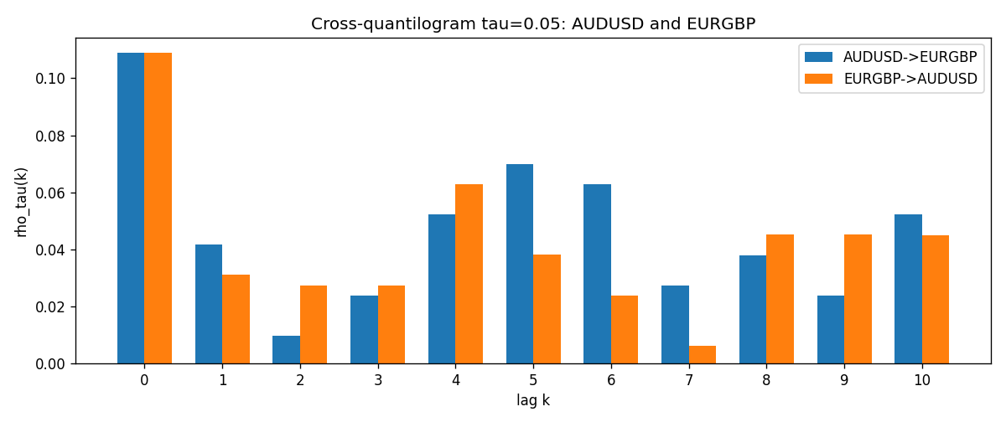

Data report
Matched rows and the CQ sheet are in the sibling Excel workbook named AUDUSD-EURGBP_CQ_D1.xlsx. Embedding all rows as a Word table is impractical; this file holds column summaries and the first and last 15 matched rows.
Columns: time, AUDUSD_open, EURGBP_open, AUDUSD_high, EURGBP_high, AUDUSD_low, EURGBP_low, AUDUSD_close, EURGBP_close, AUDUSD_tick_volume, EURGBP_tick_volume, AUDUSD_spread, EURGBP_spread, AUDUSD_real_volume, EURGBP_real_volume, AUDUSD_log_return, EURGBP_log_return, AUDUSD_h_t005, EURGBP_h_t005
Column summaries (matched calculation rows)
column | count | mean | std | min | 25% | 50% | 75% | max
AUDUSD_open | 7198 | 0.75202191 | 0.13526259 | 0.4785 | 0.6611175 | 0.731685 | 0.8091425 | 1.10284
EURGBP_open | 7198 | 0.78667202 | 0.09675257 | 0.5734 | 0.687325 | 0.83369 | 0.8651775 | 0.9769
AUDUSD_high | 7198 | 0.7560731 | 0.13582215 | 0.4878 | 0.6648025 | 0.7351 | 0.8153975 | 1.10795
EURGBP_high | 7198 | 0.7897492 | 0.09712763 | 0.5789 | 0.6894 | 0.836595 | 0.86804 | 0.9799
AUDUSD_low | 7198 | 0.74796393 | 0.1345766 | 0.4775 | 0.6578225 | 0.727775 | 0.804275 | 1.0975
EURGBP_low | 7198 | 0.7839722 | 0.09657024 | 0.5682 | 0.6853 | 0.831475 | 0.8627775 | 0.9661
AUDUSD_close | 7198 | 0.75206897 | 0.13524509 | 0.4786 | 0.661255 | 0.7318 | 0.8092725 | 1.10169
EURGBP_close | 7198 | 0.78671595 | 0.09675201 | 0.5735 | 0.687525 | 0.83375 | 0.865285 | 0.977
AUDUSD_tick_volume | 7198 | 77378.184 | 138156.24 | 109 | 5445.75 | 43349.5 | 71356.75 | 1234623
EURGBP_tick_volume | 7198 | 86961.088 | 145396.59 | 332 | 6520.25 | 44270 | 81329 | 1424684
AUDUSD_spread | 7198 | 30.809114 | 16.88495 | 0 | 13 | 30 | 50 | 50
EURGBP_spread | 7198 | 21.389692 | 19.14164 | 0 | 4 | 13 | 50 | 50
AUDUSD_real_volume | 7198 | 5.2442754e+09 | 1.2540657e+11 | 0 | 0 | 0 | 0 | 3.811512e+12
EURGBP_real_volume | 7198 | 2.7809077e+10 | 1.3507993e+11 | 0 | 0 | 0 | 0 | 3.5726265e+12
AUDUSD_log_return | 7198 | 2.054e-05 | 0.00754782 | -0.08602525 | -0.00386556 | 0.00027727 | 0.00415374 | 0.0806166
EURGBP_log_return | 7198 | 2.199e-05 | 0.00487197 | -0.03067367 | -0.00262256 | -0.00010006 | 0.00256155 | 0.06075387
AUDUSD_h_t005 | 6947 | -0.00336116 | 0.21087925 | -0.05 | -0.05 | -0.05 | -0.05 | 0.95
EURGBP_h_t005 | 6947 | -0.0114222 | 0.19260035 | -0.05 | -0.05 | -0.05 | -0.05 | 0.95
First 15 matched rows (selected columns)
time | AUDUSD_log_return | EURGBP_log_return | AUDUSD_h_t005 | EURGBP_h_t005
1999-01-06 | 0.011836351 | -0.013303338 | nan | nan
1999-01-07 | 0.0088650256 | 0.011051402 | nan | nan
1999-01-08 | 0.00031515916 | -0.004943862 | nan | nan
1999-01-11 | 0.0072213815 | -0.0012752393 | nan | nan
1999-01-12 | -0.0048608485 | 0.0033970309 | nan | nan
1999-01-13 | -0.0078902098 | 0.00042381861 | nan | nan
1999-01-14 | -0.002696916 | -0.0019793588 | nan | nan
1999-01-15 | 0.007123101 | -0.0076715819 | nan | nan
1999-01-18 | 0.00094592471 | 0.00071280921 | nan | nan
1999-01-19 | 0.0072225153 | -0.0014261269 | nan | nan
1999-01-20 | 0.0012507819 | 0.0019960086 | nan | nan
1999-01-21 | 0.00078094498 | -0.00071240297 | nan | nan
1999-01-22 | -0.012252745 | -0.0017118406 | nan | nan
1999-01-25 | -0.0039591468 | -0.0054402425 | nan | nan
1999-01-26 | 0.00047592608 | -0.00057438255 | nan | nan
Last 15 matched rows (selected columns)
time | AUDUSD_log_return | EURGBP_log_return | AUDUSD_h_t005 | EURGBP_h_t005
2026-10-13 | 0.0035007712 | 0.00020130374 | -0.05 | -0.05
2026-10-14 | -0.0015193215 | 0.0011241873 | -0.05 | -0.05
2026-10-15 | -0.0075447063 | -0.00087557391 | -0.05 | -0.05
2026-10-16 | 0.0033906408 | -0.0020380844 | -0.05 | -0.05
2026-10-19 | 0.0050859986 | -0.00056950988 | -0.05 | -0.05
2026-10-20 | 0.0034620426 | -0.0035906254 | -0.05 | -0.05
2026-10-21 | 0.0036066384 | -0.00140647 | -0.05 | -0.05
2026-10-22 | -0.0012672558 | -0.0018743924 | -0.05 | -0.05
2026-10-23 | 0.0023765656 | 0.00082421033 | -0.05 | -0.05
2026-10-26 | -0.0032032829 | 0.00013133309 | -0.05 | -0.05
2026-10-27 | 0.0016669876 | -0.0019957343 | -0.05 | -0.05
2026-10-28 | 0.0040915541 | 0.00066967224 | -0.05 | -0.05
2026-10-29 | -0.0040915541 | -0.0011722209 | -0.05 | -0.05
2026-10-30 | 0.0010102376 | -0.0024205543 | -0.05 | -0.05
2026-11-02 | -0.0049184984 | 0.00089940465 | -0.05 | -0.05

